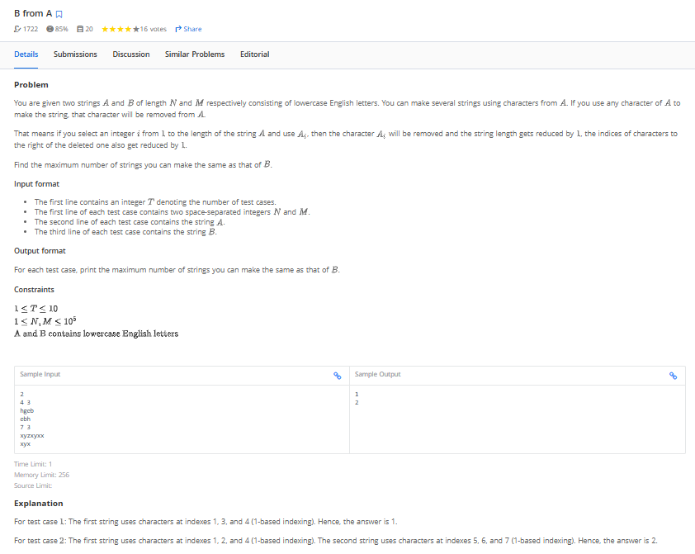

for i in range(int(input())):
N, M = map(int,input().split())
#print(N,M)

parent = input().strip()
#print(parent)

child = input().strip()
#print(child)

count = 0
pointer = 0
for ch in parent:
if ch == child[pointer]:
pointer += 1

if pointer + 1 == M:
count +=1
pointer = 0

print(count)

#----------------------------- or

# def solve():
# T = int(input()) # Number of test cases
# results = []

# for _ in range(T):
# # Read input
# N, M = map(int,input().split())
# A = input().strip()
# B = input().strip()

# # Initialize variables
# b_pointer = 0 # Pointer for string B
# count = 0 # Count of B formed

# # Iterate over characters in A
# for char in A:
# if char == B[b_pointer]:
# # move pointer to next char of B
# b_pointer += 1

# # check for complete B
# if b_pointer + 1 == M:
# # counter adds by 1
# count += 1
# # reset b_pointer for next search
# b_pointer = 0

# results.append(count)
# #print(count)

# for result in results:
# print(result)

# solve()

===================== end

